Week 1 practical

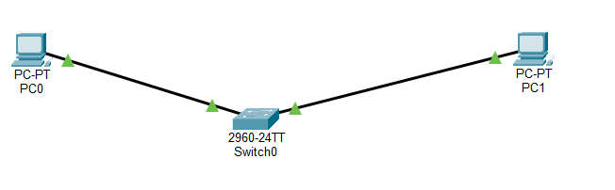

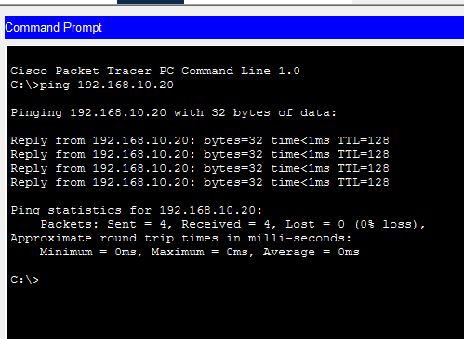

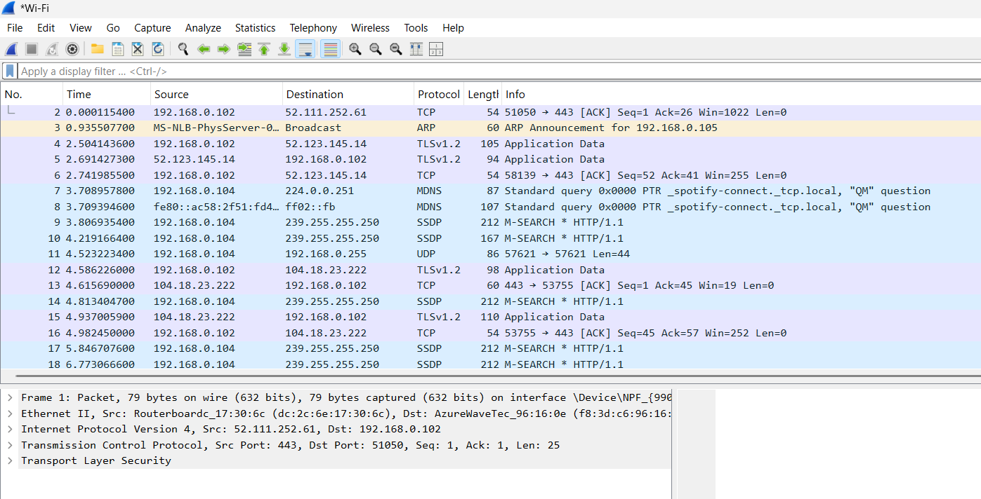

*OSI model is a theoretical framework that breaks down how computer networks communicate into seven distinct layers: physical, data link, network, transport, session, presentation, and application. Each layer has a specific role, from handling raw electrical signals at the physical layer to delivering user-facing applications at the top.
*The ping command uses the Internet Control Message Protocol (ICMP). It operates on layer 3
* Its job is to map an IP address (a logical identifier at the network layer) to a MAC address (a physical identifier used by network interfaces). It operates at the Data Link layer (Layer 2) of the OSI model.
* IP Address – is a unique number given to every device on a network so that device can identify and communicate with each other.
MAC Address – is a unique identifier assigned to a network device’s network interface card (NIC)

